**Problem Statement 1**

Find out the top 5 most visited destinations.

1. REGISTER 'piggybank.jar';
2. A = load 'DelayedFlights.csv' USING org.apache.pig.piggybank.storage.CSVExcelStorage(',','NO_MULTILINE','UNIX','SKIP_INPUT_HEADER');

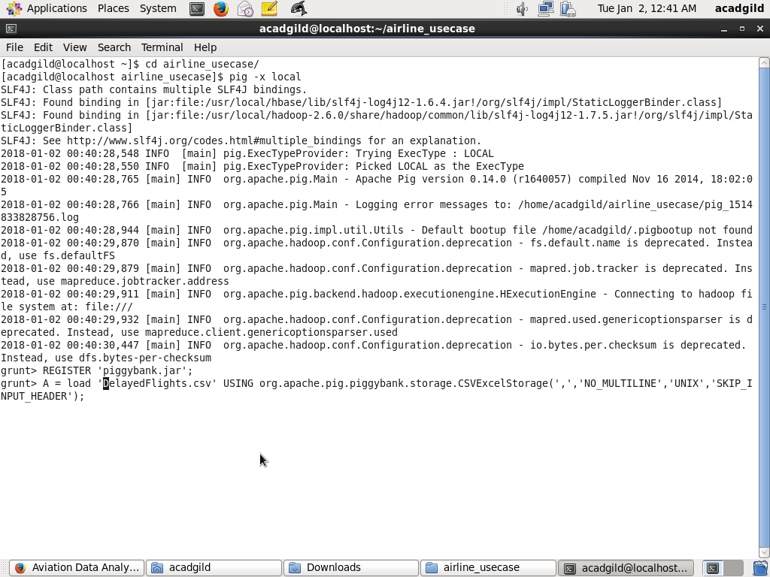

**B = foreach A generate (int)$1 as year, (int)$10 as flight_num, (chararray)$17 as origin,(chararray) $18 as dest;**

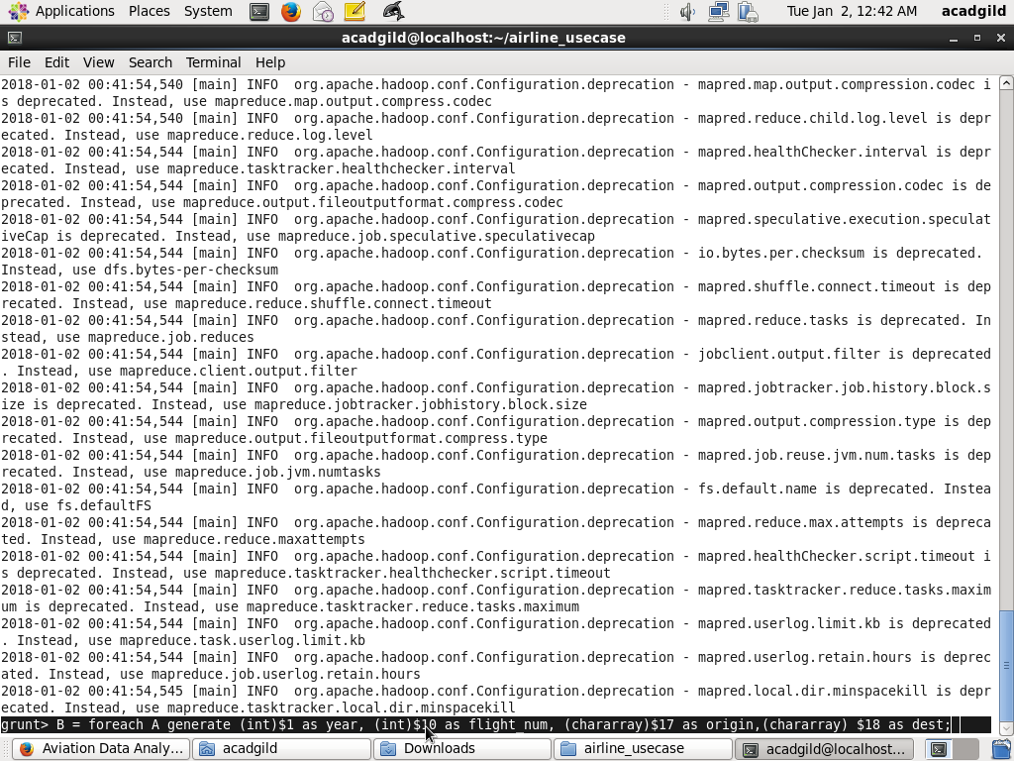

1. **C = filter B by dest is not null;**

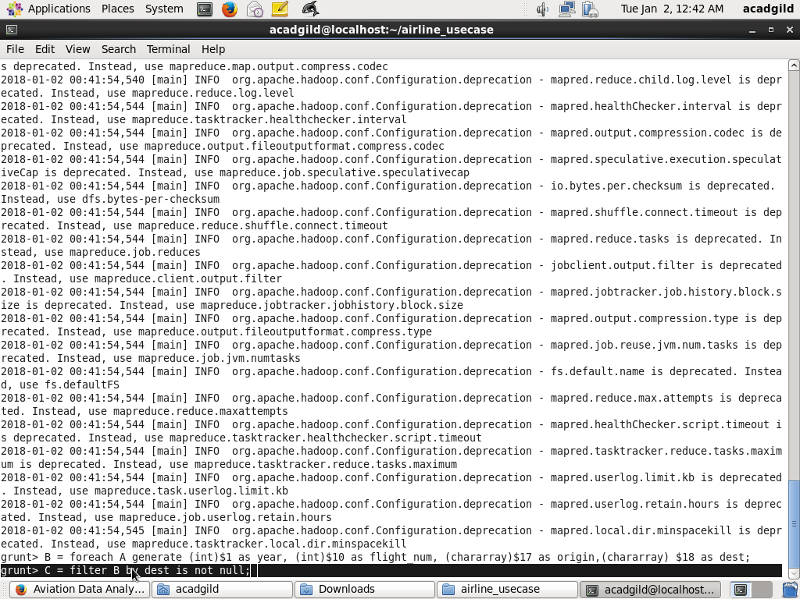

1. **D = group C by dest;**

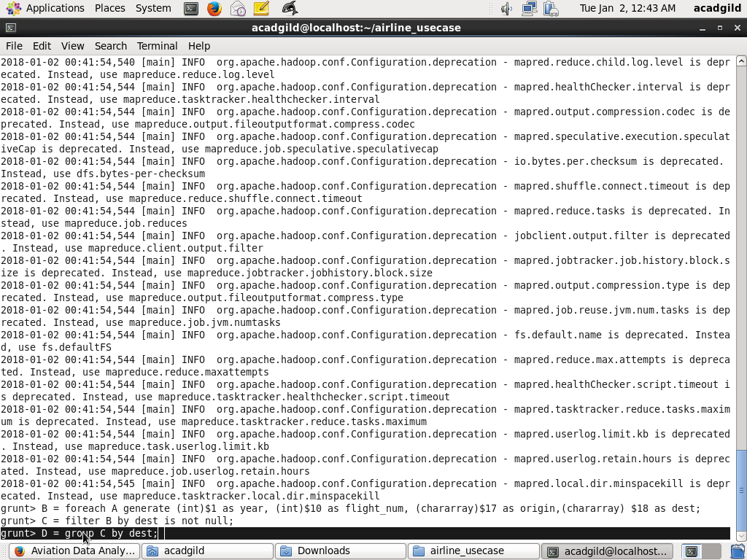

1. **E = foreach D generate group, COUNT(C.dest);**

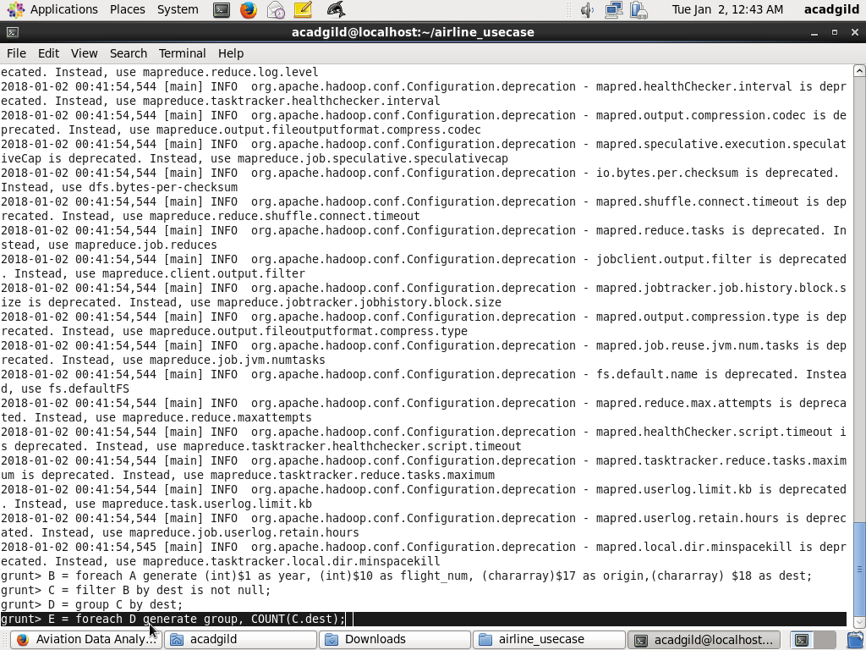

1. **F = order E by $1 DESC;**
2. **Result = LIMIT F 5;**

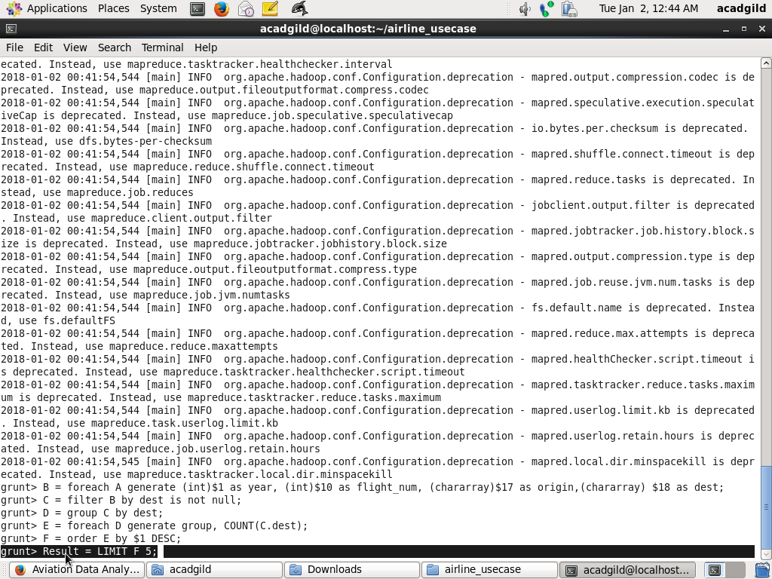

1. **A1 = load 'airports.csv' USING org.apache.pig.piggybank.storage.CSVExcelStorage(',','NO_MULTILINE','UNIX','SKIP_INPUT_HEADER');**

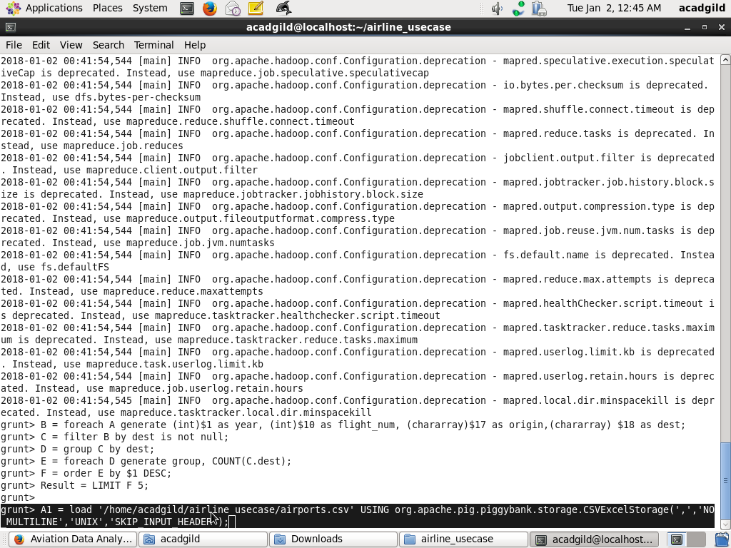

1. **A2 = foreach A1 generate (chararray)$0 as dest, (chararray)$2 as city, (chararray)$4 as country;**

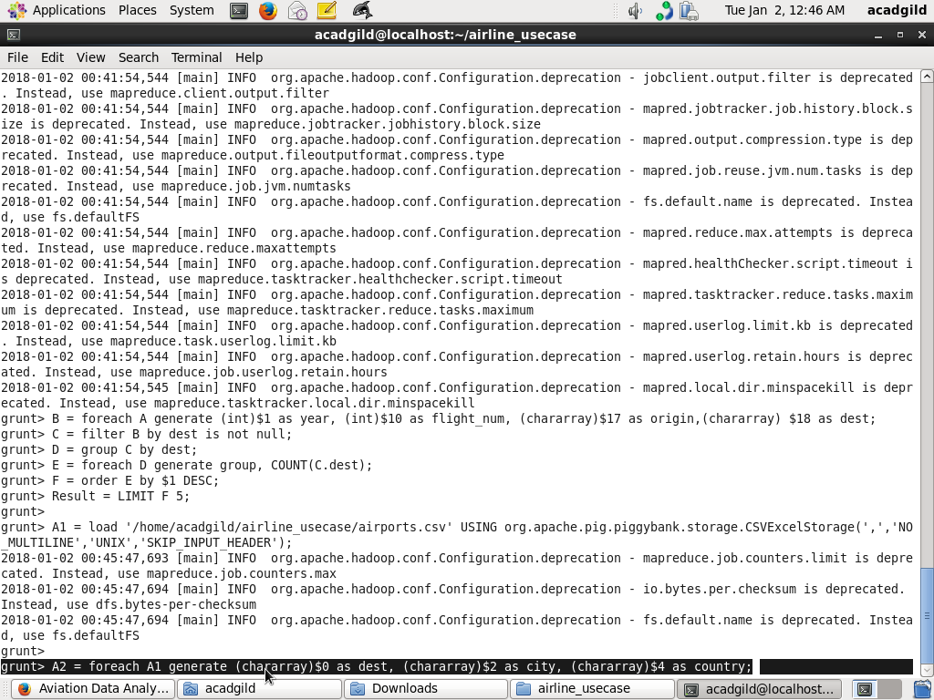

1. **joined_table = join Result by $0, A2 by dest;**

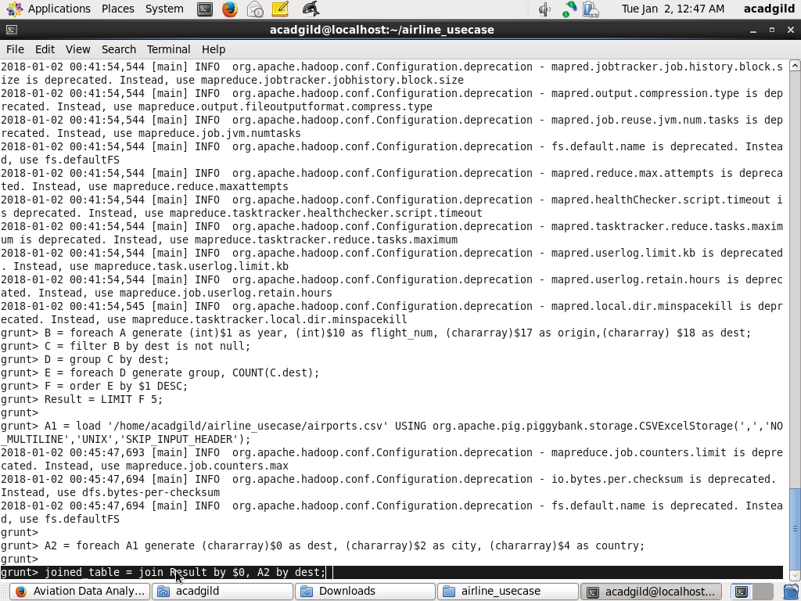

**11 . dump joined_table;**

